

Dr. D. Y. Patil Unitech Society’s

D. Y. Patil Arts, Commerce and Science College, Pimpri, Pune-18
Department of Computer Science
Academic Year 2024 - 2025

Under

Savitribai Phule Pune University

A Project Report
On

E-commerce Website

Submitted by

Omkar Patil(116)

from

S. Y. B. B. A. (Computer Application) Sem-IV

Certificate

Date:-

This is to certify that Omkar Patil have successfully completed Project titled
“E-commerce” for S.Y.B.B.A.(Computer Application) Sem-V under Savitribai Phule Pune University in the academic year 2024-2025.

Project Guide Head of the Department (Computer Science)

Internal Examiner External Examiner

Acknowledgement

There are so many people who contributed either directly or indirectly to complete this project. I shall mention few of them, who personally or professionally encouraged and assisted using the entire duration of project a very pleasant endeavor.

I am extremely thankful to our project guide prof. Yogesh Ingale for her valuable suggestions while the developing project. I am thankful to our Head of the Department Dr. Ranjit Patil Sir for his constant motivation and encouragements.

It was a fantastic and knowledgeable experience to work together in a team on project topic given to us. We learnt that a team spirit nature makes any difficult task easier and joyful.

We would also like to thank all the Teaching and Non Teaching staff members of Computer Science Department who have helped us in this project without which this project was an absolute dream for us.

Omkar Patil(116)

Project Index

Sr. No. | Content | Page No
1 | Abstract
2 | Chapter 1: Introduction  - Objective of the Project  - Existing System  - Proposed System
3 | Chapter 2: Requirement Analysis  2.1 Feasibility Study  - Software/Hardware Specification
4 | Chapter 3: System Design  3.1 E-R Diagram  3.2 Data Flow Diagram
5 | Chapter 4: Data Dictionary
6 | Chapter 5: Input Output Screen
7 | Chapter 6: Limitations  - Limitations  - Future Enhancement
8 | Chapter 8.  Bibliography

- Abstract
This report looks at the key systems that make e-commerce websites work smoothly and provide a great shopping experience. It covers how products are displayed and organized, making it easy for customers to search and find what they need. The report also explores the simple process of adding items to the cart and checking out, as well as how orders are handled, shipped, and tracked to keep customers informed. Customer support is another important part, with features like live chat and email helping to solve issues quickly. Finally, it touches on how inventory is managed, ensuring that customers always know what’s in stock. Together, these systems help e-commerce websites run efficiently, making shopping online easier and more enjoyable for everyone.

- Chapter 1: Introduction
E-commerce websites have completely changed the way we shop. Simply put, they are online platforms where businesses can sell their products or services directly to customers, making shopping as easy as clicking a button. Whether you're at home, on the go, or across the world, e-commerce sites let you shop anytime, anywhere.
These websites usually offer a wide range of products, complete with descriptions, photos, and even customer reviews, so you can make informed decisions before buying.
There also include features like simple checkout processes, and various delivery choices to make shopping as smooth as possible.
As more people use the internet and digital tools, e-commerce sites have become a must for businesses to connect with customers and stay competitive. This report will explore the main features, benefits, challenges, and current trends of e-commerce websites, giving a closer look at their impact on the modern shopping experience.

1.1 Objective of the project
- Enable Convenient Shopping: To offer customers a seamless, user-friendly shopping experience, allowing them to browse, select, and purchase items from anywhere, at any time.
- Expand Market Reach: To help businesses reach a larger, global audience by overcoming the limitations of traditional brick-and-mortar stores.
- Increase Sales and Revenue: To drive higher sales by offering customers an easy way to shop and encouraging repeat purchases through promotions, recommendations, and a smooth shopping experience.
- Enhance Customer Engagement: To build strong customer relationships through personalized experiences, recommendations, and responsive customer service.
- Efficient Inventory and Order Management: To streamline the process of tracking products, managing inventory, and handling orders, reducing operational costs and increasing efficiency.

1.2 Existing system
- Product Display & Search: E-commerce sites organize products in easy-to-browse categories, making it simple for customers to find what they’re looking for with search filters like price, size, and color.
- Shopping Cart & Checkout: After adding items to their cart, customers can easily review their selections and complete their purchase by entering payment details, choosing delivery options, and confirming the order.
- Order Fulfillment & Delivery: Once an order is placed, the system handles everything from packaging to shipping, often providing real-time tracking updates so customers know exactly when to expect their products.
- Customer Support: E-commerce websites offer support through live chat, emails, or phone calls to help with any issues, like tracking orders, returns, or product questions, ensuring a smooth customer experience.
- Inventory Management: E-commerce systems keep track of product availability and stock levels, updating the site in real time so customers know when products are in or out of stock.

  - Proposed system
- The proposed system for an e-commerce website aims to enhance the overall shopping experience by introducing new features and improvements. The idea is to make the website even easier to navigate and more efficient for both customers and businesses.
- Improved Search & Product Filters: We propose an advanced search feature with smarter filters to help customers find exactly what they’re looking for faster—whether it's based on brand, reviews, price range, or specific features.
- Faster Checkout Process: The new system will streamline the checkout experience by simplifying steps, offering guest checkouts, and adding multiple payment methods, making it easier and quicker for customers to complete their purchases.
- Real-Time Inventory Updates: To avoid frustrations, we’ll implement real-time inventory tracking that shows customers exactly what's in stock, so they’re never disappointed with out-of-stock items when checking out.
- Enhanced Customer Support: The system will offer 24/7 customer support through multiple channels, like live chat, email, and a dedicated help center. This ensures customers can get answers to their questions or resolve issues quickly.
- Smart Order Fulfillment & Shipping: The system will improve how orders are processed and shipped by integrating faster delivery options, real-time tracking, and more flexible delivery methods to give customers better control over how and when they receive their purchases.

- Chapter 2: Feasibility Study
2.1 Feasibility Study

1. Technical Feasibility:
- Tech Requirements: To make the system work, we need modern tools like a solid website platform, secure payment options, and software to track products and orders. We’ll also need to ensure everything works smoothly together.
- Growth Potential: The system should be able to grow with the business. This means it needs to be flexible and capable of handling more products, more visitors, and new features as the business expands.

2. Operational Feasibility:
- Ease of Use: The new system will be easy for both customers and staff to use. Customers will find it simple to navigate, search for products, and check out quickly. Staff will easily manage the site, update inventory, and process orders from a user-friendly admin panel.
- Customer Support: A big part of the system is offering excellent customer support. With live chat, email, and phone options, we’ll be able to handle any questions or issues quickly.
- Ongoing Support: We’ll ensure that employees are well-trained on the system and that regular updates and fixes are done to keep everything running smoothly.

3. Economic Feasibility:
- Cost vs. Benefits: While there will be an initial investment to build the system (design, software, etc.), the benefits are clear. We expect better customer experiences, leading to more sales, fewer abandoned carts, and better product availability.
- Return on Investment (ROI): Over time, this new system will not only make customers happier but also save the business money by improving efficiency. It’s expected that the business will see a good return on the investment within the next 1–2 years.
- Budget: We’ll keep an eye on the costs and compare them to the expected sales growth. The plan is to make sure the system pays for itself in a reasonable time frame.

2.2 Software/Hardware Specification

Software Specifications:
- E-Commerce Platform & CMS: We’ll use a user-friendly CMS like Shopify or WooCommerce for managing product listings, customer orders, and content. The platform will also integrate secure payment gateways like razorpay or Stripe, as well as tools for inventory management and customer support.

Hardware Specifications:
- Web Hosting & Server: The e-commerce site will be hosted on a cloud-based platform like Amazon Web Services (AWS) or Google Cloud, offering scalability and reliable performance. The server will be configured to handle traffic efficiently with at least 2 CPU cores, 4 GB RAM, and 50 GB storage.

- Chapter 3: System Design
3.1 E-R Diagram
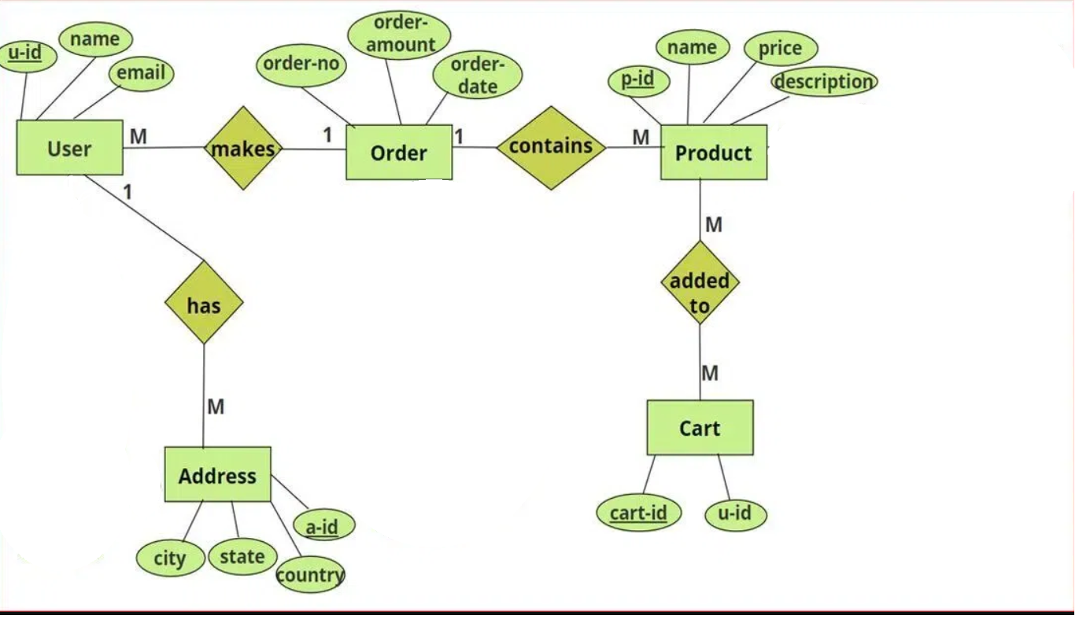

3.2 Data Flow Diagram
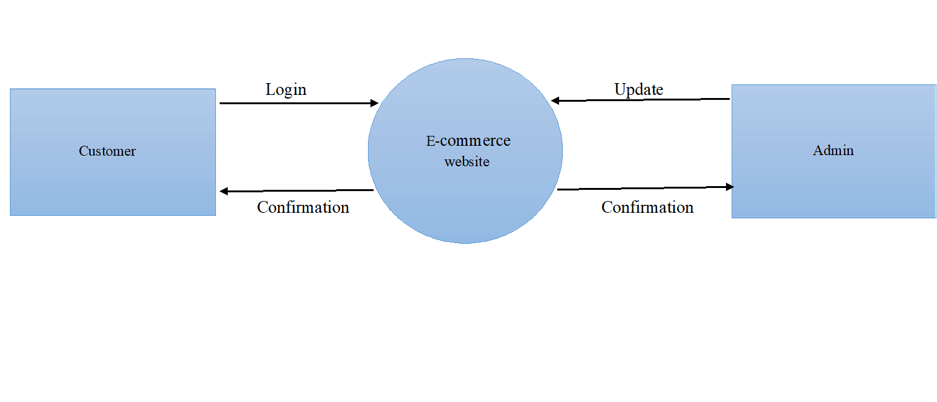
Level-0 DFD Diagram
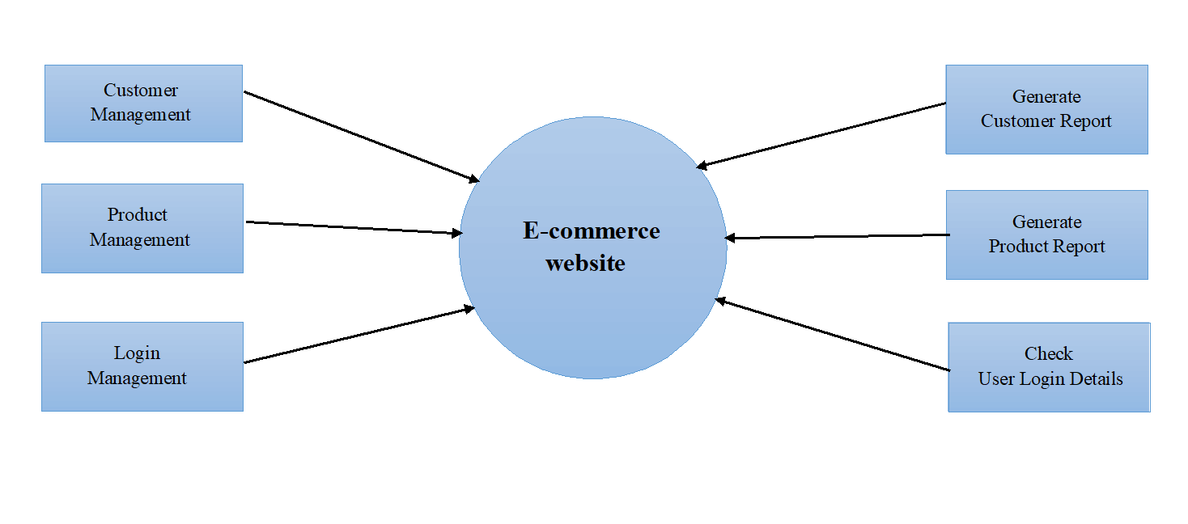
Generate
Customer Report
Level-1 DFD Diagram

- Chapter 4: Data Dictionary

1. User_table
Field Name | Data Type | Description | Constraints
user_address | VARCHAR(100) | Customer’s address | Not Null
user_mobile | VARCHAR(100) | Customer's phone number | Not Null
user_id | INT | Unique identifier for each customer | Primary Key, Auto Increment
username | VARCHAR(100) | Full name of the customer | Not Null
user_email | VARCHAR(100) | Customer's email address | Not Null
user_password | VARCHAR(255) | Hashed password for customer login | Not Null
user_image | TEXT | Customer’s Image | Not Null
user_ip | VARCHAR(15) | Customer's ip address | Not Null

2. Products
Field Name | Data Type | Description | Constraints
product_id | INT | Unique identifier for each product | Primary Key, Auto Increment
product_title | VARCHAR(100) | Name of the product | Not Null
product_Description | TEXT | Detailed description of the product | Not Null
product_price | DECIMAL(10,2) | Price of the product | Not Null
product_keyword | VARCHAR(100) | Product keyword | Not Null
category_id | INT | Foreign key referencing Category | Not Null, Foreign Key
brand_id | INT | Foreign key referencing Category | Not Null, Foreign Key
product_image1 | VARCHAR(225) | To add an image in data base | Not Null
product_image2 | VARCHAR(225) | To add an image in data base | Not Null
product_image3 | VARCHAR(225) | To add an image in data base | Not Null

3. Categories
Field Name | Data Type | Description | Constraints
category_id | INT | Unique identifier for each category | Primary Key, Auto Increment
category_title | VARCHAR(100) | Name of the product category | Not Null

4. Brands
Field Name | Data Type | Description | Constraints
brand_id | INT | Unique identifier for each category | Primary Key, Auto Increment
brand_title | VARCHAR(100) | Name of the product category | Not Null

5. Cart_detailes
Field Name | Data Type | Description | Constraints
product_id | INT | Unique identifier for each cart | Primary Key, Auto Increment
Ip_address | VARCHAR (255) | Foreign key referencing Customer | Not Null
quantity | INT | Unique identifier for each product | Not Null

6. Cart_Item
Field Name | Data Type | Description | Constraints
admin_id | INT | Unique identifier for each cart item | Primary Key, Auto Increment
admin_name | VARCHAR(100) | Name of admin | Not Null
admin_email | VARCHAR(100) | Admin’s email | Not Null
admin_password | VARCHAR(255) | Admin’s password | Not Null

- Chapter 5: Input & output screen

  - Input screen

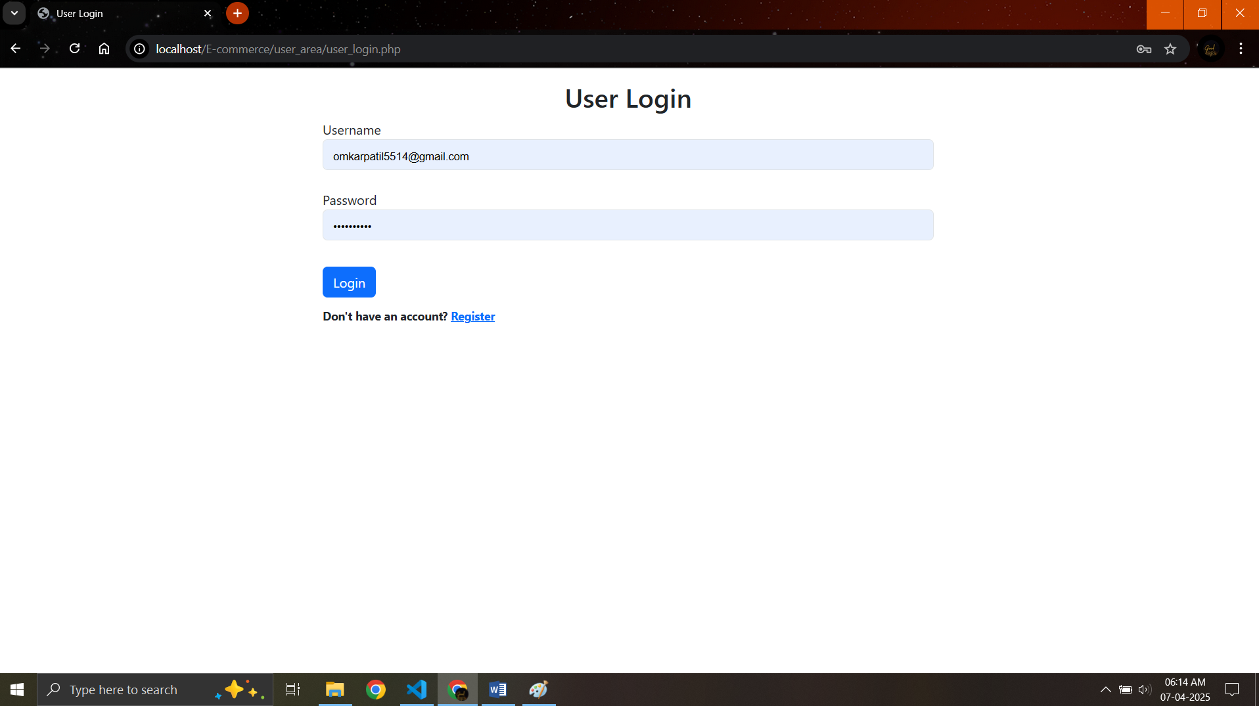

  - Output screen

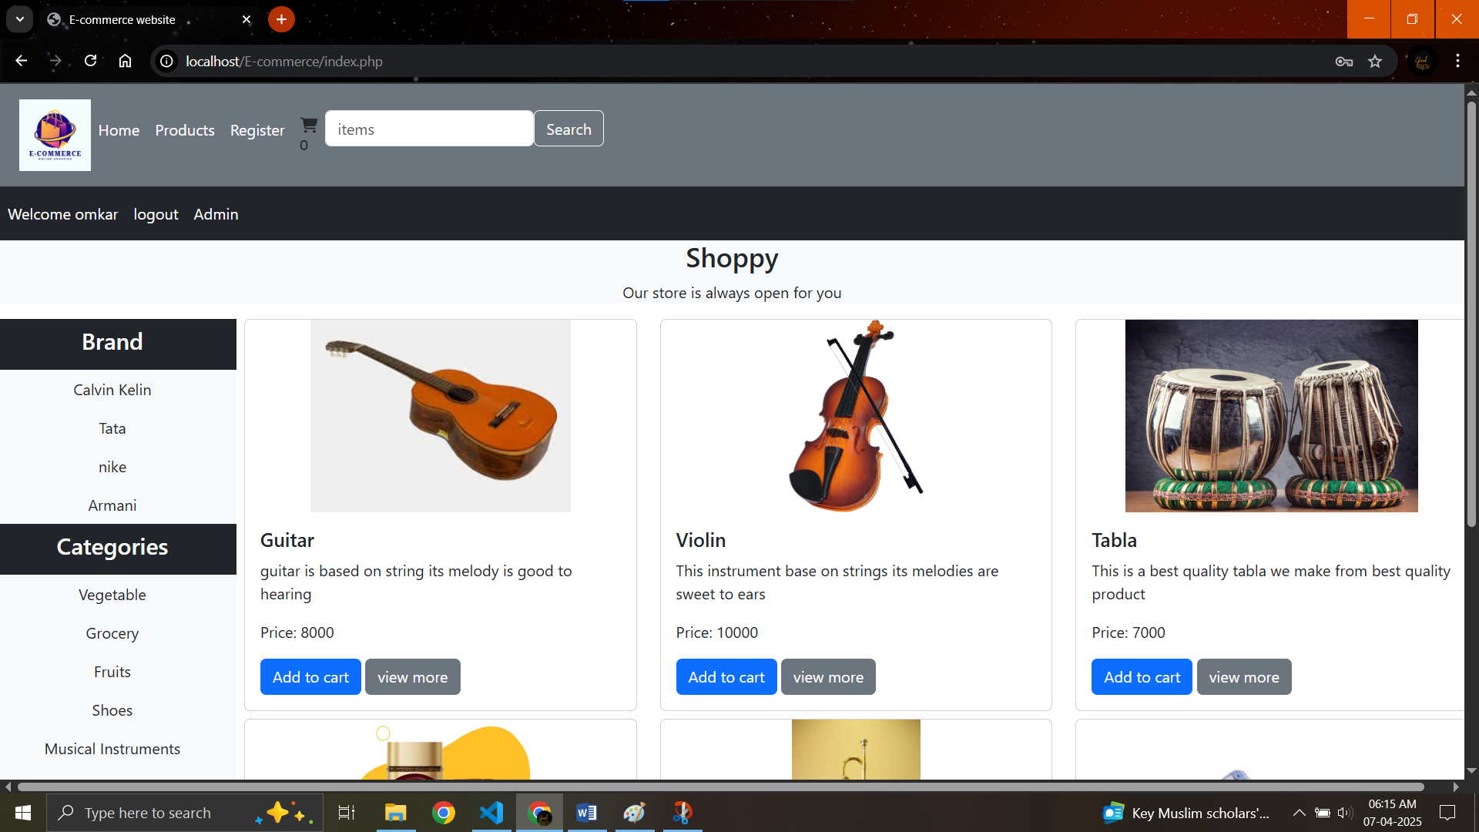

- Chapter 6: Limitation

6.1 Limitations

One of the key limitations of my e-commerce website is the current "Add to Cart" feature, which doesn't offer enough flexibility for a seamless shopping experience. While it allows users to add products to their cart, it lacks advanced functionalities like product suggestions, personalized recommendations, or the ability to easily modify quantities and variants. Additionally, there’s no option for saving items for later or integrating wishlists, which could help customers organize their shopping better. The process of reviewing and editing the cart can also feel clunky, with limited options for removing or updating items. This makes the overall shopping experience less intuitive, especially for users who might be browsing multiple items or need more control over their selections. Improving the "Add to Cart" functionality would not only enhance usability but also contribute to higher customer satisfaction and better conversion rates

6.2 Future Enhancement

In the future, one of the key enhancements I plan to make is integrating a payment option to fully complete the e-commerce experience. Right now, users can browse and add items to their cart, but without a smooth and secure way to finalize their purchases, the shopping experience is incomplete. Adding a payment gateway will allow customers to easily pay for their orders directly on the site, making it much more convenient. Whether it’s through credit/debit cards, mobile wallets, or other online payment methods, the goal is to give shoppers flexibility and security during checkout. This update will not only improve the user experience by offering a seamless, one-stop shopping journey, but also help increase conversion rates and customer satisfaction. Ultimately, completing the website with this feature will make it more competitive and provide a fully functional e-commerce platform for everyone.

- Chapter 8: Bibliography

A bibliography is just a list of all the books, articles, and websites you used to gather information for something, like a research paper or project. It's a way to give credit to the people who created the resources you used and to help others find those resources if they want to learn more.
- Chaffey’s "Digital Marketing" (2019) dives into how to run an online business, create strategies for marketing, and manage customer relationships. It’s like a roadmap for anyone building an e-commerce site.
- Laudon & Traver’s "E-commerce 2020" (2020) is a textbook that breaks down the entire e-commerce industry. It covers everything from technology to the way online shopping affects society. Think of it as the big picture of e-commerce.
- Moll’s "E-commerce Payment Systems" (2021) focuses on how online payment systems work. If you’re thinking about adding a payment option to your e-commerce site, this one’s a deep dive into how to do it securely.
- PayPal’s Article on Payment Options (2023) explains why it's important to offer multiple ways for customers to pay on your website. More payment options can lead to more successful sales, which is exactly what you want.
- Kemp’s "Digital 2023 Report" (2023) gives you up-to-date stats on how people are shopping online and using mobile payments worldwide. It’s helpful for understanding current trends in e-commerce.

